

**EE 464**

**PROJECT #2**

**Isolated Converters and Controller Design**

**Team Member: Abdurrahman Aydın**

**Yusuf Basri Yılmaz**

**OlgunErdoğan**

**Submitted to: OzanKeysan**

**Date:20.04.2018**

# Introduction

In this project, isolated converter and its controller will be designed and observed. First part, we will obtain DC voltage from DC voltage using fly-back converter. Then, we will design transformer and estimate equivalent circuit for our fly-back converter.In addition, we will calculate minimum load current for working with without getting in to DCM. Also, efficiency of converter will be observed different load conditions. Second part, controller will be designed in this part. Firstly, transfer function will be obtained. Then, transfer function will be plotted the bode plot. Also, we will obtain same characteristic with using computer simulation program.

# Comments and Simulation Results

## 1)Isolated Converter Simulation

We used fly back converter for obtaining 24 V and 100 W output from 48 V DC voltage as determined hardware project.

1. The simulation results and circuit are given as follows;

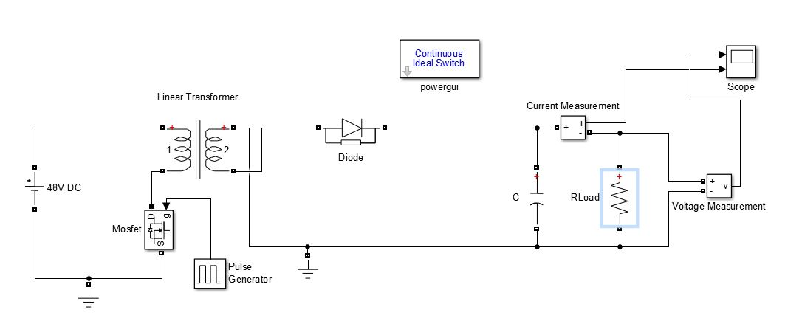

Figure 1Flyback Circuit

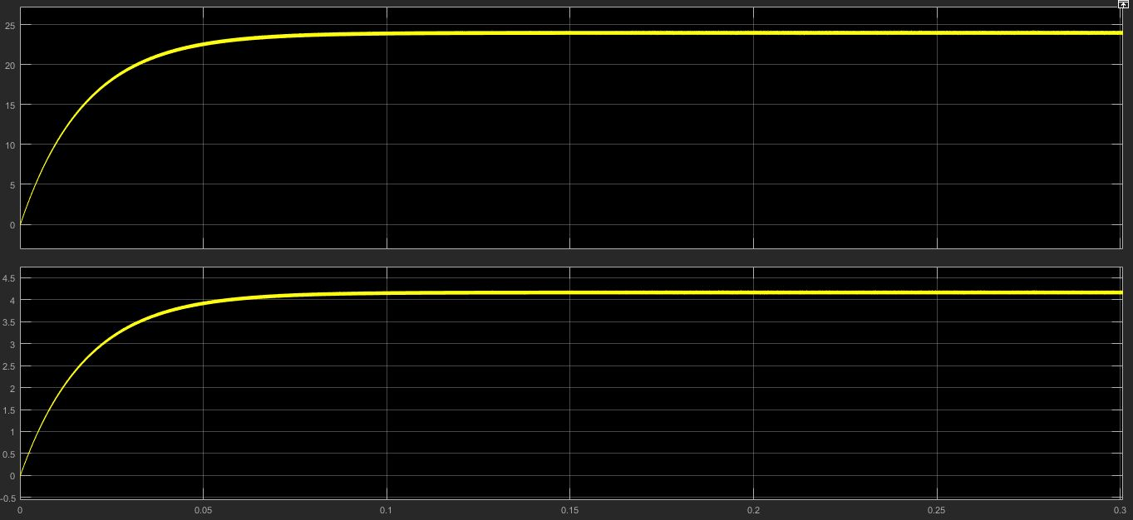

Figure 2. Simulation Result of Flyback Converter Vin=48V and Vout=24V at P=100W

b)

Input voltage Vin = 48V

Output (full load) 24 V at 4.16 A

We chose:

Switching frequency 250 kHz

Assuming Magnetizing current ripple 4% of dc magnetizing current

Duty cycle D = 0.4

Turns ratio n1/ n2 = 1.33

Fill factor Ku = 0.3 is assumed.

Pcu=5W

Maximum flux density Bmax= 0.25 Tis used. This value is less than the worst-case saturation flux density of the ferrite core material.

Components of magnetizing current, referred to primary:

$$I_{m}=\frac{n_{1}}{n_{2}}\frac{1}{1-D}\frac{V_{0}}{R_{L}}$$

$$I_{m}=5.22 A$$

∆IM=0.1044A

$$L_{m}=\frac{V_{in}DT_{s}}{2∆I_{M}}$$

=0.072mH

The rms value of the primary winding current is found as follows (this equation taken from Fundamentals of Power Electronics 2nd edition Erickson appendix A eq. (A.6));

$$I_{1rms}=I_{M}\sqrt{D}\sqrt{1+\frac{1}{3}{(\frac{{∆I}_{M}}{I_{M}})}^{2}}$$

=3.3 A

The rms value of the secondary winding current is found as follows;

$$I_{2rms}=\frac{n_{1}}{n_{2}}I_{M}\sqrt{1-D}\sqrt{1+\frac{1}{3}{(\frac{{∆I}_{M}}{I_{M}})}^{2}}$$

=5.37 A

The total rms winding current is equal to:

$$I_{total}=I_{1}+\frac{n_{2}}{n_{1}}I_{2}$$

=7.33 A

We can now determine the necessary core size.

$$K_{g}≥\frac{p{{(L}_{M}*I_{total}*I_{M,max})}^{2}}{{B_{Max}}^{2}*P_{cu}*K_{u}}*{10}^{8}$$

$$=\frac{1.724*{10}^{-6}{(0.18*{10}^{-3}*7.33*5.3)}^{2}}{{0.25}^{2}*5*0.3}$$

$$=0.0875{ cm}^{5}$$

The smallest EE core listed in figure 3 that satisfies this inequality is the ETD29, which has kg=The dimensions of this core is as follows;

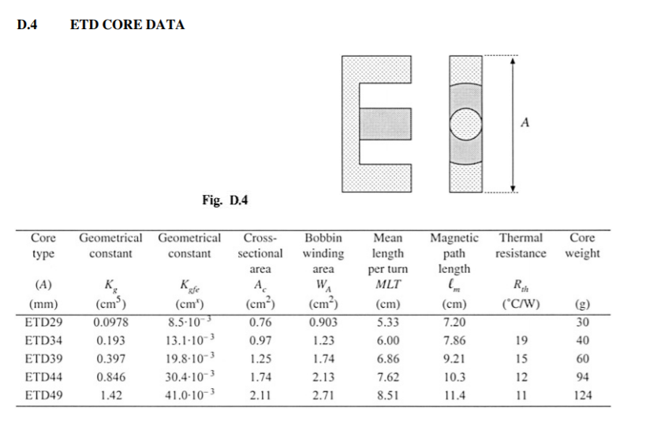

Figure 3.ETD Core Data( taken fromtaken from Fundamentals of Power Electronics2nd edition Erickson appendix D)

The air gap length is chosen as follows;

$$l_{g}=\frac{µ_{0}*{L_{M}*I_{M,max}}^{2}}{{B_{Max}}^{2}*A_{c}}*{10}^{4}=1.34 mm$$

The number of winding 1 turns is chosen as follows;

$$n_{1}=\frac{L_{M}*I_{M,max}}{B_{Max}*A_{c}}*{10}^{4}=50.21 turns$$

Since an integral number of turns is required, we round off this value to

$$n_{1}=51$$

To obtain the desired turns ratio, n2 should be chosen as follows:

$$n_{2}=\left(\frac{n_{2}}{n_{1}}\right)*n_{1}$$

$$n_{2}=38.34$$

We again round this value off, to

$$n_{2}=39 turns$$

For the flyback transformer example, the peak ac flux density is found to be as follows;

$$ΔB=\frac{V_{in}*T_{s}*D}{{2*n}_{1}*A_{c}}=0.01 T$$

c)

When average magnetization current equal to half of the ripple on magnetization current system goes DCM mode.

$$I_{M,avg}=\frac{ΔI_{M}}{2}=\frac{V_{in}DT_{s}}{2L_{m}}=0.533 A$$

$$I_{L}=\left(1-D\right)I_{M,avg}*\frac{n_{1}}{n_{2}}=0.425 A$$

0.425 A is minimum current of load for working with without getting into the DCM.

d)

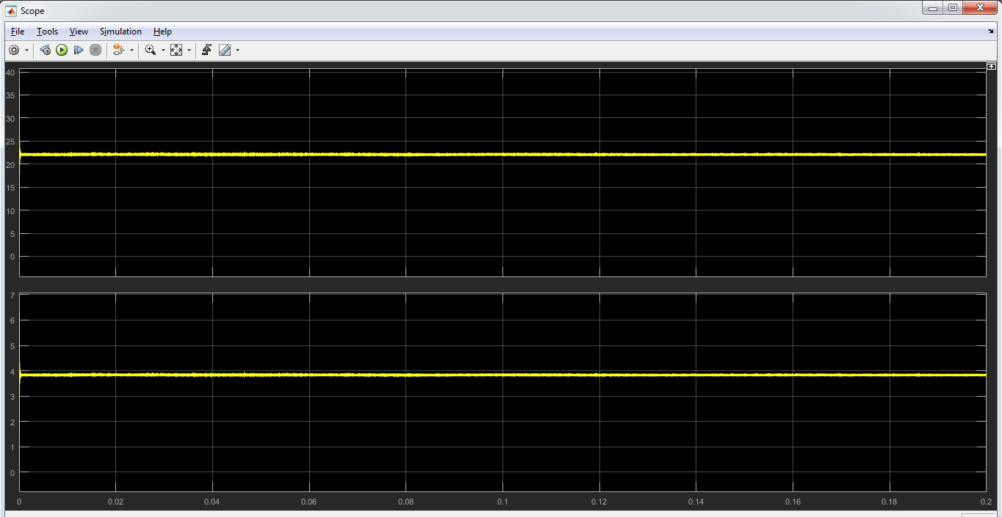

*Figure 4- Waveform of output voltage and current with non-ideal switches*

When we add non-ideal switches to the count, output voltage and current decrease. The reason of that is voltage drop on swtiches. On the other hand, we include leakage inductance and see their results.

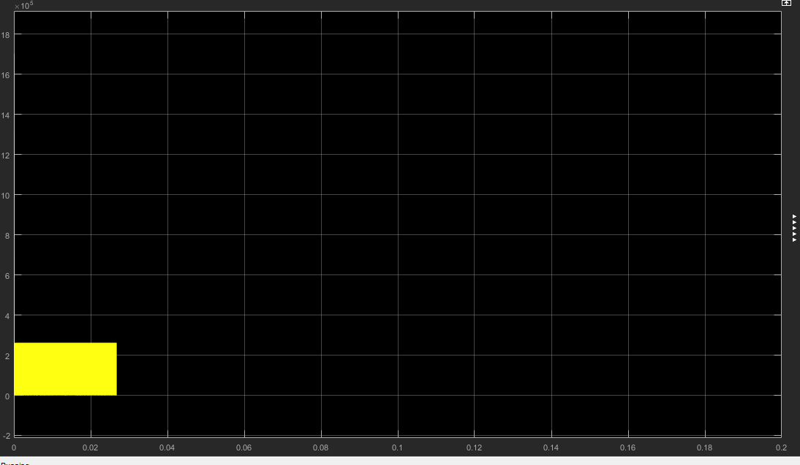

*Figure 5- Mosfet voltage drop without snubber*

We need to design snubber. We will use RC snubber. We choose R is 5 ohm and C as 660 mikroFarad.

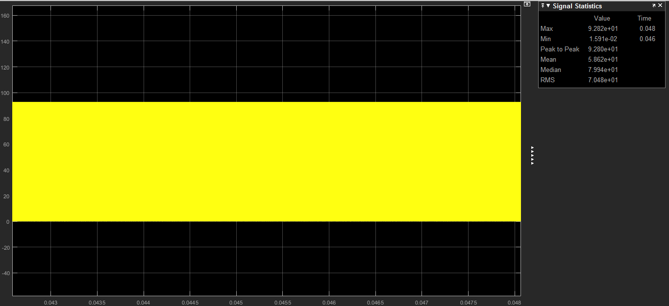

*Figure 6- Mosfet voltage drop with RC snubber*

As can be seen from Figure, by using snubber , voltage drop on Mosfet decreases. This situation increases life long of Mosfet. Maximum voltage drop on mosfet is 141 V.

e)

|  |  |  |  |  |  |  |  |
| --- | --- | --- | --- | --- | --- | --- | --- |
|  | V_out | I_out | P_out | V_in | I_in | P_in | Eff |
| 100% | 22.2 | 3.85 | 85.47 | 48 | 2.54 | 121.92 | 70% |
| 75% | 21.98 | 2.88 | 63.3 | 48 | 1.926 | 92.45 | 68.46% |
| 50% | 21.9 | 1.92 | 42.05 | 48 | 1.32 | 63.36 | 66.37% |
| 25% | 22.52 | 0.978 | 22.02 | 48 | 0.75 | 36 | 61.17% |

*Table 1- Power outputs for different loads*

For smaller loads, efficiency decreases. Output and input power decrease.

f)

2)

a) Let’s choose buck converter and analyze it;

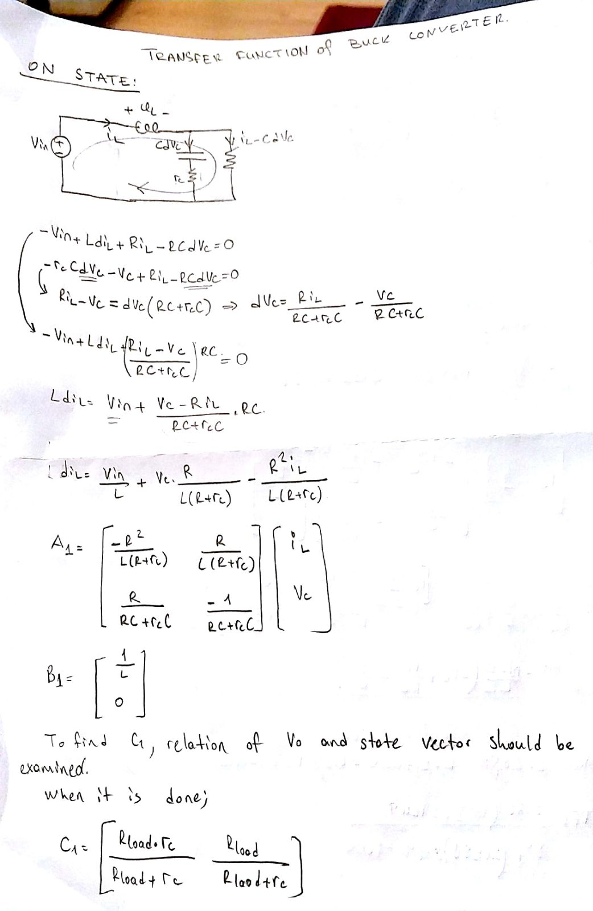

*Figure 5- Transfer Function ON-State Analysis*

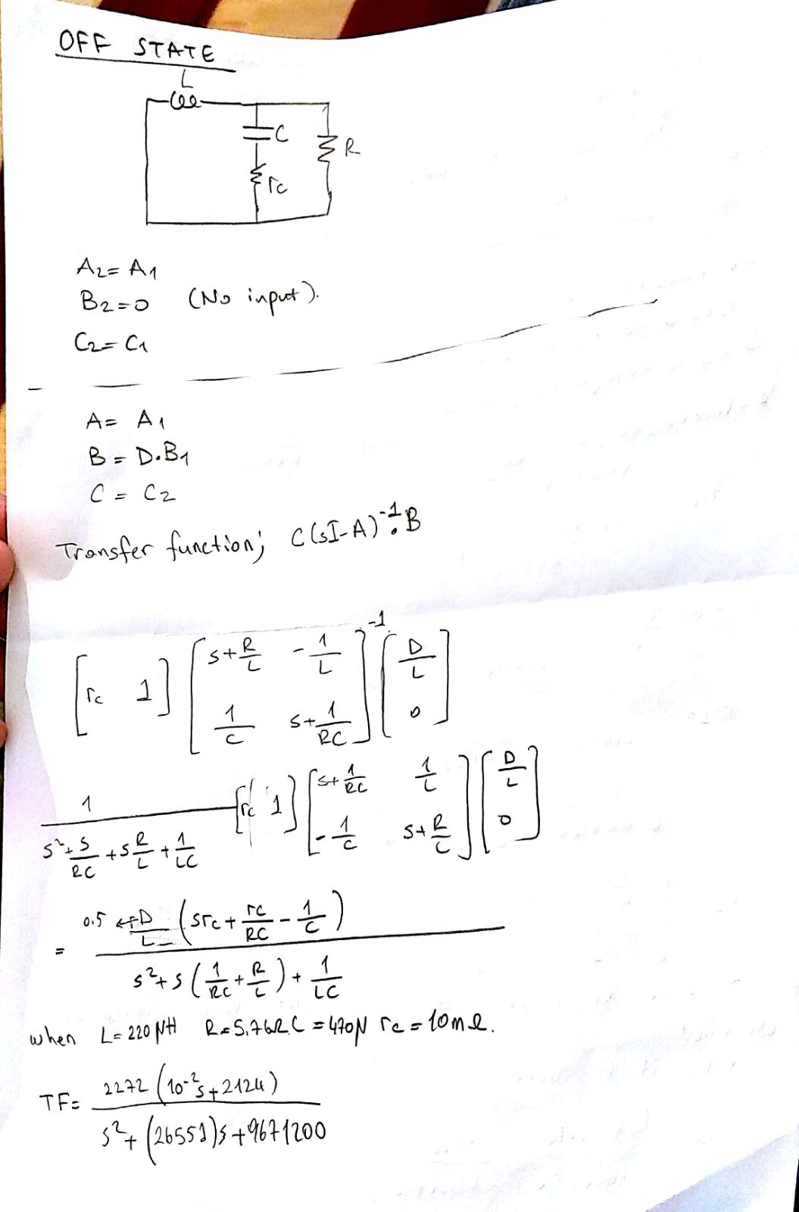

*Figure 6- Transfer Function OFF-State Analysis and Combining States*



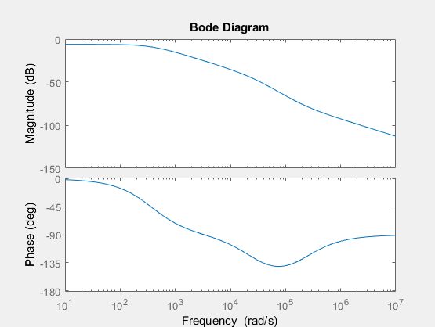

*Figure 7- Bode Plot of the Transfer Function Obtained by Hand*

b)

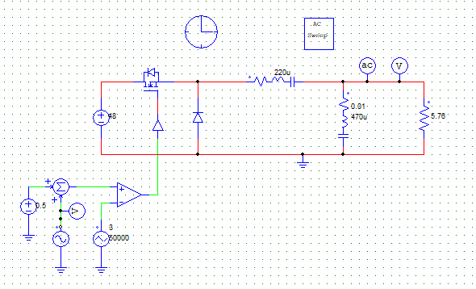

*Figure8- PSIM Simulation for Obtaining Bode Plot*

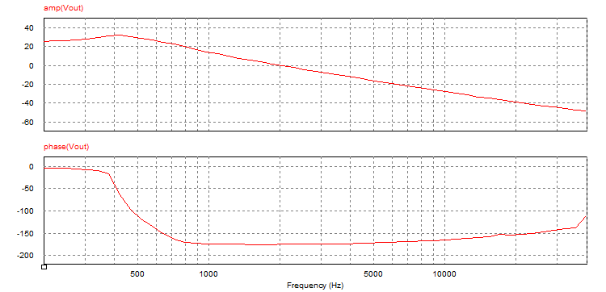

*Figure 9- Bode Plot of the Buck Converter*

As seen in Figures 7 & 9, bode plots are not the same. This means that we have made a mistake when obtaining the transfer function analytically but could not find where the mistake is. In Figure 9, there is only 5°phase margin and it should be improved by a controller to have a better transient response.